Sri Lanka Institute of Information

Technology



Lab Submission

05

**IT24101937**

**Athukorala M.B**

B.Sc. (Hons) in Information Technology

(1)

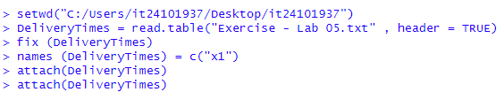

**(2)**

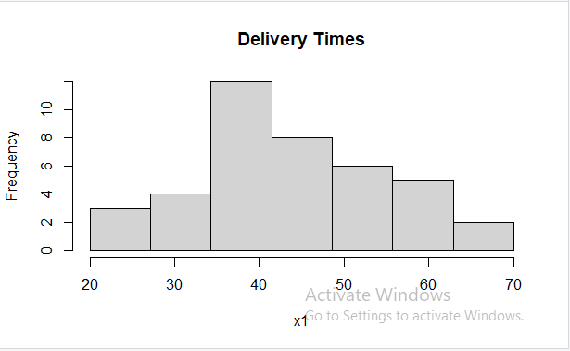

**(3)**

**The histogram shows the freqency at which delivary has taken place.**

**Theres a sharp incline at the ~35 ~40 mark**

**(4)**







